Contract # 582-16-60180
PGA and Notice to Commence # 582-16-60849-01
Deliverable 2.1.1

Ambient Monitoring

QUALITY ASSURANCE PROJECT PLAN (QAPP)

QA Category III: Measurement Project

Revision 1

Janurary 11th, 2016

Prepared by the:

Natural Resources Department of the
Alamo Area Council of Governments

PREPARED UNDER A GRANT FROM THE
TEXAS COMMISSION ON ENVIRONMENTAL QUALITY

The preparation of this report was financed through grants from the State of Texas through the Texas Commission on Environmental Quality (TCEQ).
The content, findings, opinions and conclusions are the work of the author(s) and do not necessarily represent findings, opinions or conclusions of TCEQ.

Title and Approval Sheet

The purpose of this project is for the Alamo Area Council of Governments (AACOG) to operate and maintain ozone and meteorological instruments for ambient monitoring in the south central region of Texas within the 13-county service territory of AACOG. Specific details about the project and the roles and responsibilities of participants appear in Section 2, Organization and Responsibilities.

This document is a Category III Quality Assurance Project Plan for the Ambient Monitoring Project being conducted in the AACOG region of south central Texas. This QAPP is deliverable 2.1.1 for Task 2 – Ambient Monitoring Projects found in the FY 2016-2017 Proposal for Grant Activities (PGA) and Notice to Commence No.: #582-16-60180. This QAPP document outline follows Category III National Risk Management Research Laboratory (NRMRL) Quality Assurance Project Plan (QAPP) Requirements for Measurement Projects.

This project is funded and overseen by the Texas Commission on Environmental Quality (TCEQ). The project is managed by the Natural Resources Department of AACOG.

_________________________________________________ ______________
Lyle Hufstetler Date
Natural Resources/Transportation Specialist, AACOG

_________________________________________________ ______________
Steven Smeltzer Date
Project Manager, AACOG

_________________________________________________ ______________
Brenda Williams Date
Contract Director, AACOG

Distribution List

Below is a list of individuals and their organizations who should receive copies of the approved QA Project Plan and any subsequent revisions, including all persons responsible for implementation (e.g., project managers), the QA managers, and representatives of all groups involved. Paper copies need not be provided to individuals if equivalent electronic information systems can be used.

Texas Commission on Environmental Quality – Central Office

Dr. Bright Dornblaser, Project Manager TCEQ
Atmospheric Scientist
Technical Analysis Division
Texas Commission on Environmental Quality
12100 Park 35 Circle, Bldg. E, Austin, TX 78753
Mail: MC-164, P.O. Box 13087, Austin, TX 78711-3087
desk: 512 239-1978
Bright.Dornblaser@tceq.texas.gov

Principal Investigator / Quality Officer

Steven Smeltzer, Project Manager
Alamo Area Council of Governments
8700 Tesoro Drive, Suite 700
San Antonio, Texas 78217
phone: (210) 362-5266

TABLE OF CONTENTS
Title and Approval Sheet 2
Distribution List 3
TABLE OF CONTENTS 4
TABLES 4
FIGURES 4
1 PROJECT DESCRIPTION AND OBJECTIVES 5
1.1 Project Description 5
1.2 Project Objectives and Goals 5
1.3 Project Background 6
2 ORGANIZATION AND RESPONSIBILITIES 8
2.1 Project Organization Chart 8
2.2 Project Schedule / Key Milestones 8
3 SCIENTIFIC APPROACH 10
4 SAMPLING PROCEDURES 13
5 MEASUREMENT PROCEDURES 14
5.1 AACOG Ozone Equipment: 15
6 QUALITY METRICS (QA/QC CHECKS) 16
7 DATA ANALYSIS, INTERPRETATION, AND MANAGEMENT 20
7.1 Data Analysis and Interpretation 20
7.2 Data Management 20
8 DATA REPORTING 21
9 REFERENCES 21
Appendix A: Ozone Monitor Placement 22
Appendix B: Monitoring Site Equipment Inventory List 24

TABLES
Table 1-1: AACOG Ambient Air Quality Monitor Locations, Parameters, 1st Day of Operation 6
Table 2-1: Summary of project schedule and milestones 9
Table 6-1: Site Maintenance diagram, Data Verification and Shutdown Schedule for 2016-2017 17
Table 6-2: QA Requirements for QAPP of four categories 18

FIGURES
Figure 3-1: 2001 Ozone Monitoring Sites in the San Antonio Area 10
Figure 3-2: 2001 study by TCEQ Network Design Team 11
Figure 5-1: Typical physical layout of ozone monitoring equipment 14

PROJECT DESCRIPTION AND OBJECTIVES

The San Antonio – New Braunfels Metropolitan Statistical Area (SA-NB MSA) recorded ambient ozone levels on local regulatory ozone monitors which are in excess of the 2008 federal 8-hour average ozone national ambient air quality standards (8-hour ozone NAAQS) both during the 2011-2013 and 2012-2014 averaging periods. On October 1, 2015 the U.S. Environmental Protection Agency (EPA) revised the ozone NAAQS from 75 parts per billion (ppb) to 70 ppb.

Project Description

Through this project, the Alamo Area Council of Governments (AACOG) will operate and maintain ozone and meteorological instruments for ambient monitoring in the south central region of Texas within the 13-county service territory of AACOG. These measurements will complement the data collected by TCEQ’s regulatory monitors and other ozone instruments in the region to provide a more comprehensive regional coverage for ozone measurements.

The data collected from AACOG’s monitoring operations will support and enhance knowledge of ambient ozone levels in the greater San Antonio area, will assist local elected officials in their understanding of ozone movement, and will assist local technical assessments related to an understanding of local ozone emissions on the formation and movement of ozone in the region. AACOG is responsible for the collection of ambient monitoring data at these monitoring sites and for the electronic transfer of the data to the TCEQ’s Leading Environmental Analysis and Display System (LEADS) on a near-“real-time” basis during the entire ozone season. This public display of the data supports public education and outreach goals for both the TCEQ and AACOG. Air monitoring equipment and data reporting is continuous between March 1, 2016 and midnight November 15, 2016 and between March 1, 2017 and midnight November 15, 2017 under the conditions of the FY 2016-2017 PGA No. 582-16-60849-01.

Project Objectives and Goals

The objective of this project is for AACOG to maintain and operate ozone and meteorological monitoring in the AACOG region in order to better characterize regional ozone levels. The data collected from the local monitoring operations will support and enhance knowledge of ambient ozone levels in the greater San Antonio area, will assist local elected officials in their understanding of ozone movement, and will assist local technical assessments related to an understanding of local ozone emissions on the formation and movement of ozone in the region. As such, data provided by the AACOG Ozone and Meteorological Monitoring Network supports local efforts to reduce local ozone levels through voluntary planning as written into the Mission, Goals and Objectives of the Bylaws of the Air Improvement Resources Committee.

The first goal in establishing the AACOG Ozone and Meteorological Monitoring Network was
- To augment the existing regulatory monitoring network for ambient ozone data collection.
The air quality monitoring provided by the AACOG Ozone and Meteorological Monitoring Network was also designed to assist both citizens and local air quality planners in accomplishing at least three additional goals:
- Assess Population Exposure: extending the monitoring network allows a more comprehensive estimation of exposure of citizens to ambient ozone levels. Students, such as school children, are among at-risk health populations for ozone exposure;
- Photochemical model performance verification: how well does the photochemical model predict ozone levels across the modeling region? The photochemical model is the most valuable and trusted method of predicting changes in ozone levels when various ozone control strategies are in place, and of forecasting the ozone levels in future years with and without control strategies. As such, verification of the model’s accuracy is very important to achieving successful regional air quality planning; and
- Education: extending the monitoring network allows public awareness of ozone levels and associated health risks where people work, live, and travel in the San Antonio region. Moreover, placing this data collection equipment at host schools will facilitate increased science education on air quality/pollution issues.

Table 1-1: AACOG Ambient Air Quality Monitor Locations, Parameters, 1st Day of Operation
Site Name, Location  (CAMS Number) | Parameters  reported | First day of operation
Elm Creek Elementary School,  11535 Pearsall Road, Atascosa, TX 78002-5150 (C501) | Ozone & Meteorology* | June 17, 2002
Bulverde Elementary School,  1715 E. Ammann Road, Bulverde, TX 78163-2034 (C503) | Ozone | August 26, 2002
National Weather Service Station / New Braunfels Airport, 2090 Airport Road, New Braunfels, TX 78130 (ozone: C504; meteorology: C5004) | Ozone | August 30, 2002 (ozone)
City of Garden Ridge, 21340 FM 3009, near Garden Ridge, TX 78266 (C505) | Ozone | March 26, 2003
Seguin Outdoor Learning Center, 1865 East Highway 90, Seguin, TX 78155 (C506) | Ozone | March 26, 2003
* “Meteorology” indicates: Wind Speed, Resultant Wind Speed, Resultant Wind Direction, Maximum Wind Gust, Std. Dev. Wind Direction, Outdoor Temperature, Precipitation. Note that the meteorological data set available through C5004 at the National Weather Service Station is more extensive: http://www.tceq.state.tx.us/cgi-bin/compliance/monops/site_photo.pl?cams=5004

Project Background

Because the eight counties which comprise the SA-NB MSA are all within the service area of AACOG, the Natural Resource department of AACOG has established, with the financial and planning support of the state of Texas and the TCEQ, five additional ozone monitor locations.

In 2002 and 2003, AACOG collaborated with regional schools, city governments, the National Weather Service, and the Texas Natural Resource Conservation Commission (TNRCC, now the Texas Commission on Environmental Quality or TCEQ) to install ozone and meteorological monitoring equipment in the AACOG region of south central Texas in support and enhancement of the existing regulatory ozone monitors established by TCEQ in the region.

At the request of local elected officials acting in the Air Improvement Resources (AIR) Executive Committee which convenes at AACOG headquarters, the ozone sites were established specifically such that the data generated would NOT be used for regulatory determinations.

Functionally, the AACOG ozone and meteorological network was the first installation of its kind, in that the non-regulatory or “ozone lite” installations utilized a less rigorous procedure for site determination and establishment than EPA regulatory guidance required, and so were less costly to establish and maintain. First envisioned by Bryan Lambeth, retired staff meteorologist with TCEQ, the site determination procedure allowed collaborations with schools and local governments to use public properties for site locations. Since the sites established under this procedure would not meet requirements for regulatory data collection, the project was approved by the local elected officials on the Air Improvement Resources Executive Committee.

The sites established under this procedure allowed a greater number of sites for the same level of funding; therefore, the site selection process allowed planners to distribute a greater number of monitors across the San Antonio region than regulatory site establishment could permit. By partnering with schools for site locations, pre-existing shelters for the instruments also meant determination of ozone levels where children, a risk group for ozone exposure, were at study and play.

The ozone and meteorological monitoring equipment owned by AACOG and operated under subcontract through AACOG is operated during the ozone season in San Antonio, defined by TCEQ as April 1 through October 31. The first two weeks of November are included in the operation and maintenance subcontract period for seasonal shut-down and mothballing of the equipment. Unlike previous years, the FY 16-17 Ambient Monitoring plan calls for beginning ambient monitoring on March 1, rather than April 1 and for monitoring through November 15, rather than October 31.

ORGANIZATION AND RESPONSIBILITIES

The individuals and organizations participating in this project are
- the Texas Commission on Environmental Quality (TCEQ),
- the Alamo Area Council of Governments

Project Sponsor: The TCEQ is sponsoring the operations and maintenance of the AACOG Ozone and Meteorological Monitoring Network comprising five monitoring sites, each of which are provided ozone measurement instruments to measure ambient ozone levels. Two of these sites are provided with meteorological equipment as well; one is co-located at a National Weather Service Station as well, supplying additional meteorological data to the network. TCEQ defined the project, approves plans and reports. The Fair Oaks (C502) will be decommissioned and will not operate in 2016 and 2017. Due to overgrown trees and the proximity to a new two-story building, the monitor does not take accurate readings, does not meet EPA’s recommended location standards, and cannot be lowered for maintenance.

Prime Contractor: AACOG follows the direction of the TCEQ management in all operations, and AACOG, through the subcontractor assuring maintenance and operations of the network, provides ambient ozone readings to TCEQ.

Subcontractor: A subcontractor will be selected through requests for quotes (RFQ) to manage daily operations, required maintenance, quality controls, and provide personnel to oversee these tasks.

Project Organization Chart

Lyle Hufstetler
Natural Resources/
Transportation Specialist
QA/QC Manager, AACOG
210-362-5225
Steven Smeltzer
Project Manager
AACOG
210-362-5266

AACOG’s Ozone Monitoring
Sub-contractor
To be selected

Project Schedule / Key Milestones

Deliverable: AACOG is responsible for the collection of ambient monitoring data at monitoring sites listed in Table 1-1: AACOG Ambient Air Quality Monitoring Locations, Parameters, 1st Day of Operation, and for the electronic transfer of the data to the TCEQ’s LEADS system on a near-“real-time” basis. End-of-season maintenance and decommissioning activities will also be performed by AACOG.

Deliverable Dates: Air monitoring continuously between March 1st, 2016 to midnight November 15th, 2016 and from March 1st, 2017 to midnight November 15th, 2017. End-of-season maintenance and decommissioning activities must be completed by November 30, 2016 and November 30, 2017, respectively.

Table 2-1: Summary of project schedule and milestones
Work Element | Deliverable Date
Deliverable 2.1.1: QAPP  Drafts submitted to TCEQ for review and approval | October 14th, 2015
Revision 1 of the QAPP submitted to TCEQ for review and approval | January 11th, 2016
Deliverable 2.1.2: Ambient monitoring data for ozone and meteorological conditions | November 30, 2017

SCIENTIFIC APPROACH

Procedures for Locating Monitors for Sampling; Design Rationale

Figure 3-1: 2001 Ozone Monitoring Sites in the San Antonio Area
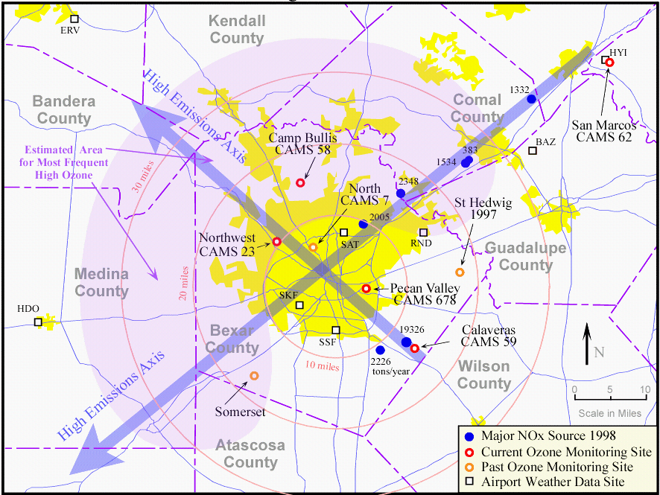

The process for site selection occurred in 2001 with guidance provided both by the US Environmental Protection Agency (EPA) and the Texas Commission on Environmental Quality (TCEQ). An historical document recording the early considerations for site selection is attached here as Attachment A: Ozone Monitor Placement. This document was provided as a handout to the Air Improvement Resources Technical Committee of the Alamo Area Council of Governments (AIR Tech) on November 19, 2001. The AIR Technical Committee is charged with guiding local policy makers regarding technical air quality matters.

All site locations were selected in close cooperation between the TCEQ Technical Analysis Staff, the TCEQ Network Design Team, and the AIR Tech Committee. Site selection criteria were originally considered as noted in Attachment A; site selection was constrained by EPA guidance relative to instrument placement (relative to local traffic conditions, etc.) and availability of property.

Figure 3-2 illustrates, in yellow-shaded circles, regions of generally or potentially homogeneous ozone concentrations centered around regulatory sites existing in 2001. The blue-shaded circles are centered around local San Antonio schools; their overlay suggests coverage of the city such locations could provide.

In fact, as noted in Table 1-1, the final locations of AACOG’s ozone and meteorological monitors are within public or private education centers (Elm Creek Elementary School, Bulverde Elementary School, Seguin Outdoor Learning Center) or in government facilities (the National Weather Service Station in New Braunfels and the City Hall compounds for the Cities of Fair Oaks Ranch and Garden Ridge).

A full description of all equipment and instrumentation owned by AACOG and situated at the five monitoring locations is provided in Attachment B: Monitoring Site Equipment Inventory List. The Fair Oaks (C502) will be decommissioned and will not operate in 2016 and 2017. Due to overgrown trees and the proximity to a new two-story building, the monitor does not take accurate readings, does not meet EPA’s recommended location standards, and cannot be lowered for maintenance.

Figure 3-2: 2001 study by TCEQ Network Design Team
Location of AACOG ozone and meteorological monitoring network sites. Yellow-shaded circles (radius ~4 miles) denote proposed representative coverage of existing (2001) regulatory sites. Blue-shaded circles are centered on schools as possible site locations.
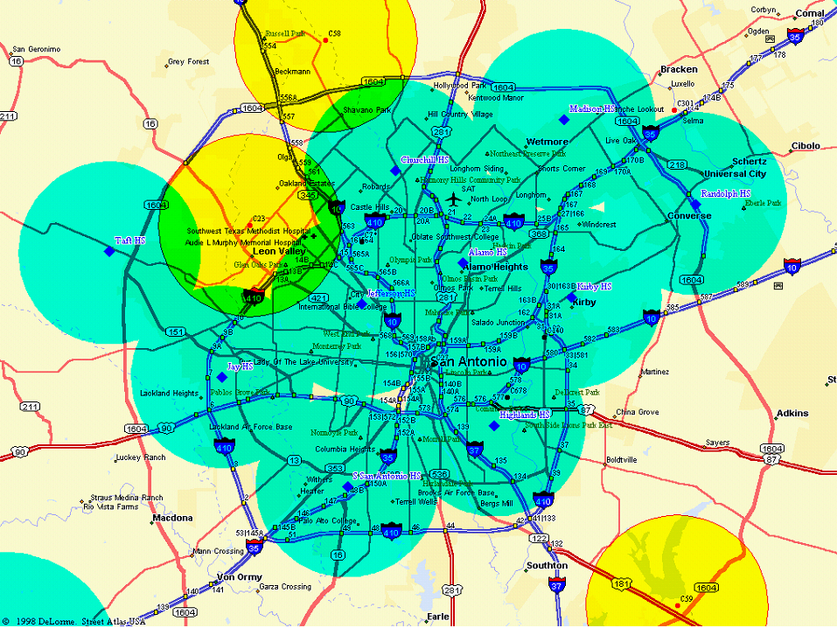

The unique target analyte for each sample taken in the project is ambient ozone.

The ozone and meteorological monitors listed in Table 1-1 operate 24 hours/day and seven days/week between March 1 and November 15. The data is relayed to TCEQ via modem or uplink every 15 minutes for entry into the TCEQ’s Leading Environmental Analysis and Display System (LEADS) on a near-“real-time” basis during the entire ozone season.

SAMPLING PROCEDURES

As noted in 3 Scientific Approach, all site locations were selected in close cooperation between the TCEQ Technical Analysis Staff, the TCEQ Network Design Team, and the AIR Technical Committee. Site selection criteria were originally considered as noted in Attachment A; site selection was constrained by EPA guidance relative to instrument placement (relative to local traffic conditions, etc.) and availability of property. As such, there are not known site-specific factors that may affect sampling procedures.

The data from the O₃ analyzers is collected using a Zeno 3200 data logger manufactured by Coastal Environmental Systems. The ozone data is collected in units of ppm with an internal offset of 0.009 ppm. Wind direction, wind speed, air temperature, and rainfall totals will also be collected at two of the five AACOG locations (refer to Table 1). Additional hardware required for ozone sampling at the five AACOG monitors is given in Attachment B.

The data collection afforded by the O₃ analyzers does not require sample procedures or calibration methods unique to each sample taken; rather, there are QA/QC checks on the calibration of the instruments described elsewhere in this document. Similarly, there are no applicable procedures for sample treatment and preparation such as homogenizing, composting, or splitting of samples. Similarly, air samples are not stored, numbered, packed, shipped or otherwise handled and preserved for future analysis in this project.

MEASUREMENT PROCEDURES

Figure 5-1: Typical physical layout of ozone monitoring equipment
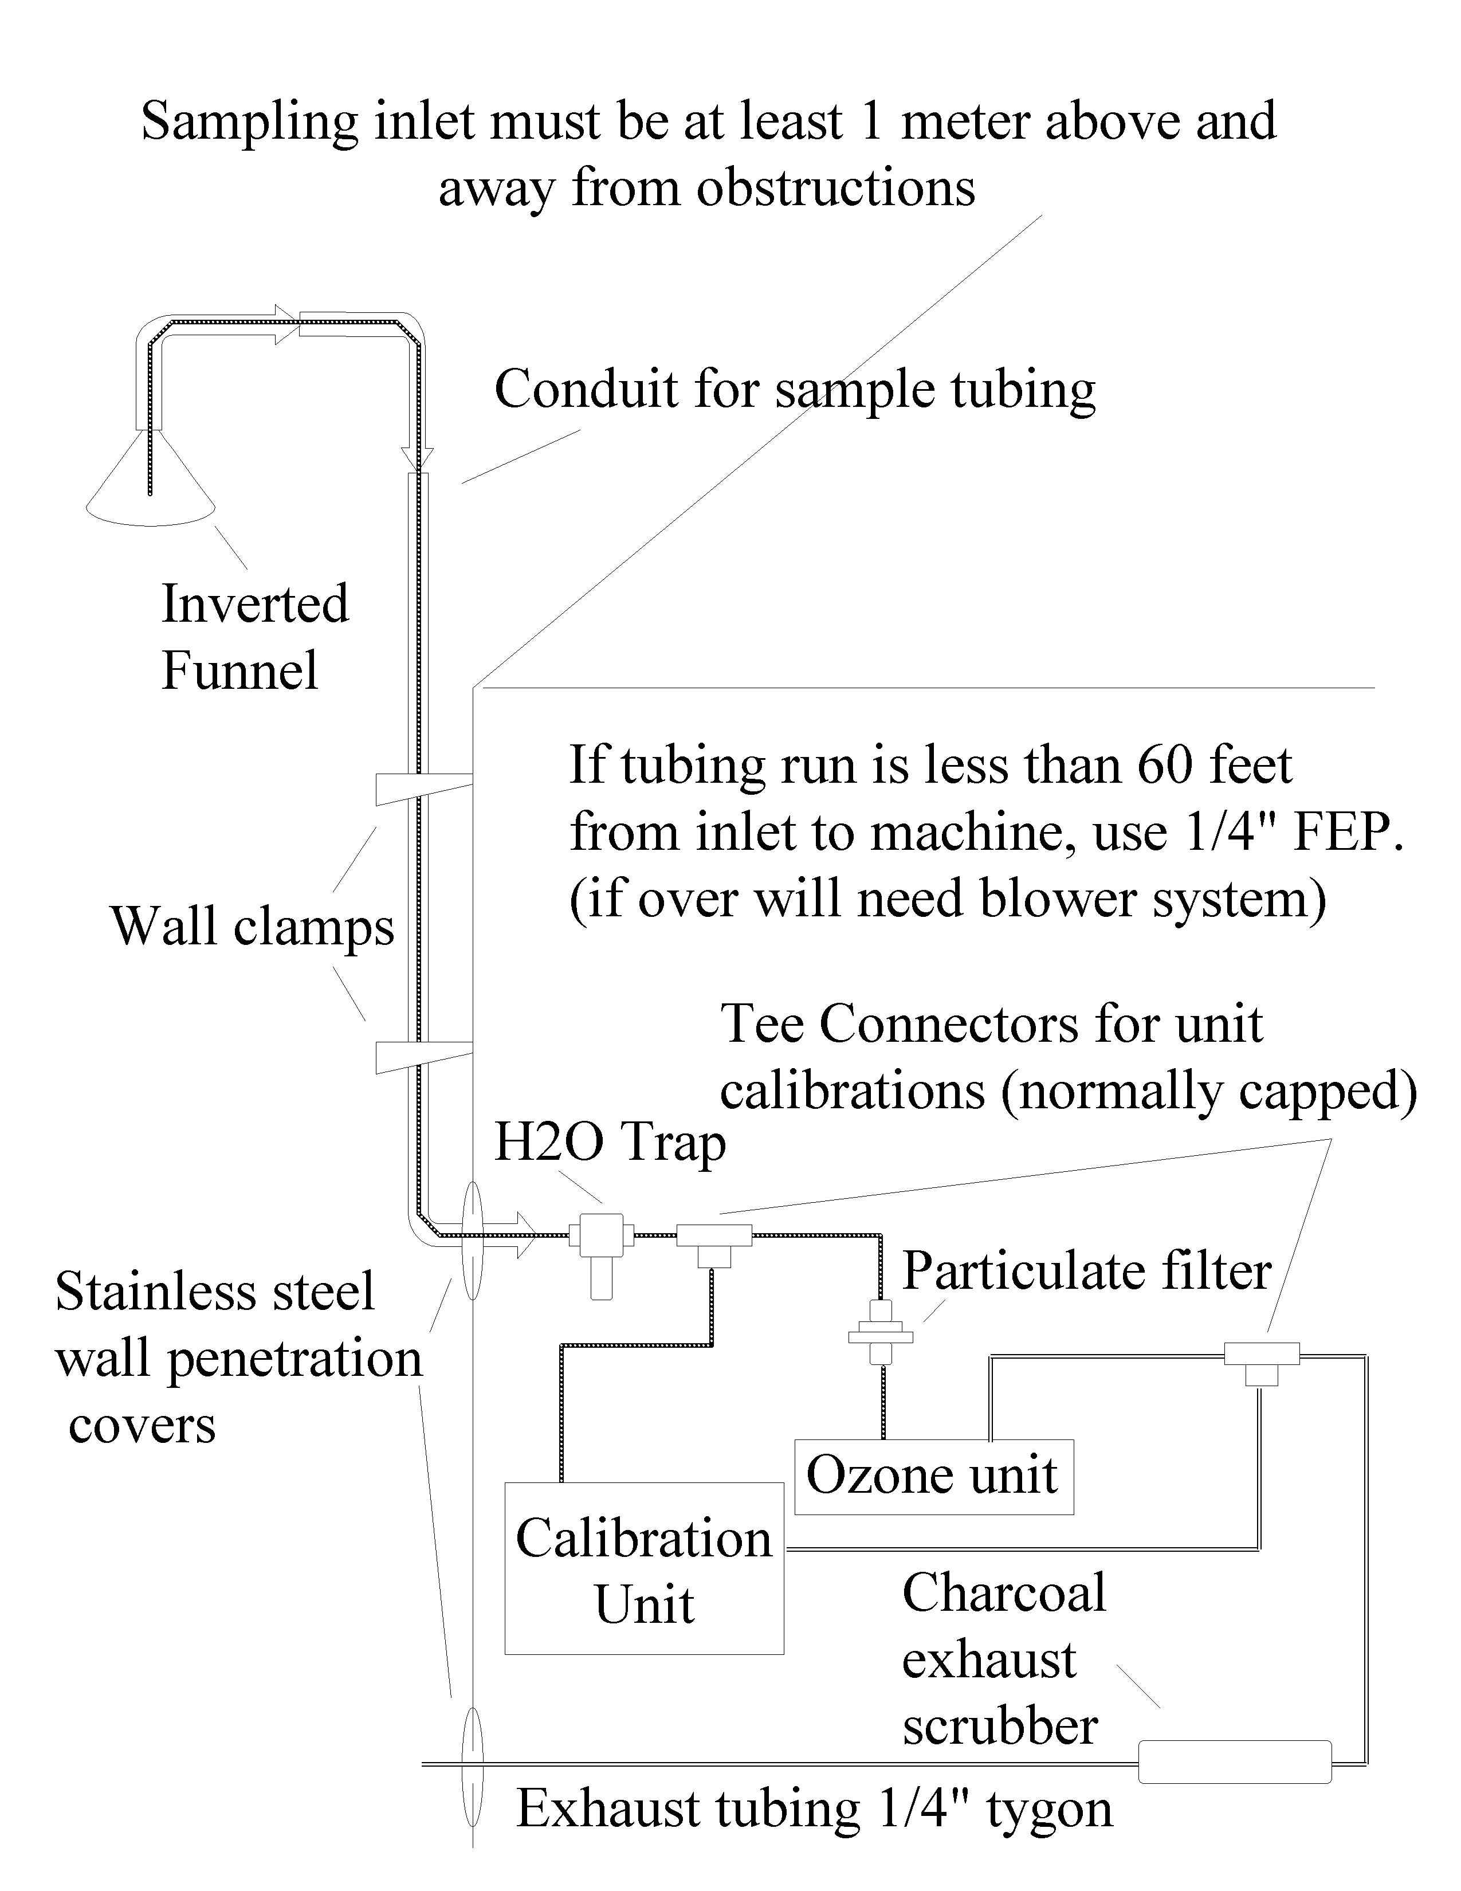

AACOG Ozone Equipment:
The five ozone analyzers currently installed in the existing locations are Thermo Environmental Instruments, Model 49C. Data loggers are all Coastal Environmental Zeno-3200 Data Loggers. The modems are US Robotics 56K Sportster models. Cole-Parmer Inline 47-mm Filter Holder, P/N-U-06621-40. UPS Backup / Surge protectors at each site.

AACOG Meteorological Equipment
R.M. Young Wind Monitor, P/N-05305 VP; R.M. Young Platinum Temperature Probe, P/N-41342 VF; R.M. Young Multiplate Radiation Shield, P/N-41002 P; R.M. Young Tipping Bucket Rain Gauge, P/N-52203.

Associated AACOG-owned Equipment for Meteorological Installation:
Climatronics Corporation tower (33 feet tall), P/N-C33-G0-H1

The data from the O₃ analyzers will be collected using a Zeno 3200 data logger manufactured by Coastal Environmental Systems. Spare Zeno 3200 data loggers will be available should the primary data collection recorder malfunction. The ozone data will be collected in units of ppm with an internal offset of 0.009 ppm. Wind direction, wind speed, air temperature, and rainfall totals will also be collected at one of the five AACOG locations.

The O₃ concentration measurements will be reported in units of parts per billion (ppb). Wind speed will be reported in miles per hour (mph); wind direction will be reported in degrees relative to magnetic north; and air temperature will be reported in degrees Celsius. The data recorded at the AACOG sites will be reported on the TCEQ website as Ozone (ppb), Wind Speed (mph), Resultant Wind Speed (mph), Resultant Wind Direction (degrees), Maximum Wind Gust (mph), Standard Deviation Wind Direction, Outdoor Temperature (degrees Fahrenheit), and Precipitation (inches) information.

The O₃ concentration measurements from the analyzers will be collected using the data recording devices indicated above. "Data Reporting" as a contractual item for subcontractors charged with maintenance and operation of AACOG's ozone and meteorological monitoring instruments requires that the contractor assure that the data logger / modem system continues to return data from the monitoring site to TCEQ's main offices in Austin. Data reporting includes a written report furnished by the contractor to AACOG at the end of each ozone season which summarizes the data return rate, reports errors and the general operational history of the site for each of the five sites.

QUALITY METRICS (QA/QC CHECKS)

This section presents the quality objectives for the project. A variation of the formal data quality objectives process as described in the U.S. Environmental Protection Agency (EPA) document Requirements for Environmental Data Operations, EPA QA/R5 has been applied to this project. The key to quality in this Ambient Monitoring Project is the operations and maintenance of the ozone monitors according to appropriate procedures. While these monitors have not been established and are not operated to provide regulatory data for the region, the quality assurance processes listed below are observed.

The following procedures to achieve appropriate QA/QC are required of all contractors responsible for daily operations and maintenance of the AACOG monitoring stations:

The contractor assures the quality of the data, which involves several processes. These processes are to be documented in the electronic station operator's log. These quality control / quality assurance checks and maintenance equipment procedures include:

- Every ozone monitor will receive a monthly calibration check during each month of operation (March 1 - November 15), as follows:

- A five-point calibration will be performed and documented at least three times each season by the contractor: once as part of the start-up procedure; once during mid-season; and once at the end of the season. In addition, a five-point calibration will be performed before and after any ozone instrument span setting adjustment and after any instrument repair or replacement. Data logger must be set to flag ozone data “QAS” during any ozone instrument calibration.
- A three-point calibration will be performed at least once a month during months that a five-point calibration is not performed. Data logger must be set to flag ozone data “QAS” during any ozone instrument calibration.
- In addition to the monthly tasks in (a) and (b) above, a zero instrument check will be performed before and after any ozone instrument zero setting adjustment.
- For all instrument calibration checks, the challenge concentration must be maintained for at least 10 clock minutes (two full data logger 5-minute averages) to provide verification of the checks. Data logger must be set to flag ozone data “QAS” during any ozone instrument calibration.
- At least once per month, check for ozone data zero flat-line as an indicator of instrument zero offset and adjust instrument zero if offset is 5 ppb or greater.

- Change out air sample line (1/4” Teflon sample line) once every year.

- Site visits at least once a month to perform cleaning (e.g., cleaning of cooling filter pad), filter replacement (e.g., replacement of particulate filter) and checks (e.g., check inline water trap) of equipment and sample inlet. (The calibration checks may be performed during these visits.)

- A schedule of checks performed at all monitors and the results from the checks will be provided by the contractor to AACOG by November 30th following every ozone season

- Each site will be shut down within two weeks after the end of the operation period, by November 30th, unless another arrangement is specified.

The contractor provides the transfer standard equipment required in the above ozone procedures, which will be calibrated using TCEQ’s primary standard. This contractor-owned transfer standard will be calibrated according to TCEQ specifications, policies and procedures.

The contractor provides the calibrator and standard necessary to complete all ozone calibrations. The instruments will be such that TCEQ's specifications, policies and procedures for calibration procedures can be met both in terms of calibrating the transfer standard at TCEQ headquarters and in terms of performing field calibrations. The goal is to be able to perform data QA/QC procedures on the AACOG instruments that match or exceed the data QA/QC procedures performed on monitors used for regulatory determinations.

Table 6-1: Site Maintenance diagram, Data Verification and Shutdown Schedule for 2016-2017
Month  Data Check | March | April | May | June | July | Aug. | Sept. | Oct. | Nov.
3- or 5-pt. calibration, data zero check | Once Monthly | Once monthly | Once monthly | Once monthly | Once monthly | Once monthly | Once monthly | Once monthly | Shut down Sites by Nov. 15, 2016 and November 15, 2017
Simple data verification (remote; online) | Daily | Daily | Daily | Daily | Daily | Daily | Daily | Daily
Equipment maintenance (clean, filter replace, flow rate check, etc.) | Every 15 days during the period from March 1 through November 15, during each of the two ozone seasons under contract
Change air sample line | Once every year

The payment of the contractor is based on performance of each monitor in the network on a day-by-day basis. The ozone season in the San Antonio region begins annually on April 1 and ends on October 31 (see Table 6-1). The monitors will be operated for a total of seventeen months for the two ozone seasons under a biennial contract, form the daily pro-rata basis for cost calculations in the payment schedule.

The contractor is responsible for completing the following data validation and reporting tasks.

- The name "Data Validation" refers here to the comparison of mid-day ozone measurements to nearest ozone site(s) at least twice per week during ozone season and the performing of collocated ozone checks if consistent difference of 20% or more is detected over a period of at least three days under conditions when ozone levels should be relatively uniform in comparison to nearby sites. Data Validation also includes daily checks over the Internet to assure that the equipment continues to report data online and functions properly, including a determination by the contractor that the data is complete. Data Validation also includes validation of data on a monthly basis by comparison and completeness of calibration events.
- "Data Reporting" requires that the contractor assure that the data logger / modem system continues to return data from the monitoring site to TCEQ's main offices in Austin. Data reporting includes a written report furnished by the contractor to AACOG at the end of each ozone season which summarizes the data return rate, and reports errors and the general operational history of the site for each of the five sites, to be reported in a "Maintenance Reporting Table." This table will be adapted for use in data reporting for each monitor operated by the contractor under the operations and maintenance contract.
- At all times during the contract period, the contractor will alert the Director of Natural Resources of AACOG or other responsible AACOG staff to the appearance of any anomalies in the data reported, whether the anomaly is due to hardware or software problems, to meteorological or ozone equipment difficulties or changes, or to contractor or TCEQ equipment difficulties or failures, etc.

Since the instruments are not operated year-round, the annual start-up procedure includes:
- Verifying the correct operation of the equipment (i.e., Zeno data logger, ozone analyzer, sample intake line, filter, water trap, modem, UPS power supply). This task will include replacement of the zero scrubber, one on each of the existing five ozone monitors.
- Calibrating each monitor following such verification, as shown in the calibration schedule above. This transfer standard will be calibrated according to TCEQ specifications, policies and procedures.
- Verifying data delivery by modem to the Texas Commission on Environmental Quality.
The monitors are to be operational no later than noon of March 1.

As a Category III QAPP, this document follows requirements provided by the TCEQ shown in the Table 6-2 below.

Table 6-2: QA Requirements for QAPP of four categories
QA Requirement | Category I | Category II | Category III | Category IV
Technical Systems Audits | Required for each project | Required for each project | Not Required for the Project | Not Required for the Project
Audits of Data Quality* | Required (50% of the data sets) | Required (25% of the data sets) | Required (10%) | Not Required
Report of QA Findings | Required in draft final and final report | Required in draft final and final report | Required in final report | Required in final report
*If problems are found, all data sets will be audited. This includes independent verification of every spreadsheet or automated calculation once and the percentage shown of manual calculations.

Audit of Data Quality is defined as an examination of data to determine if the data objectives specified in the QAPP were met for the project. As described in this section, the series and schedule of five-point and three-point calibrations as well as the zero instrument checks provide the data quality audits appropriate for this process. The measurements will be reviewed and utilized by AACOG technical staff.

DATA ANALYSIS, INTERPRETATION, AND MANAGEMENT

Data Analysis and Interpretation

There are no contractual obligations for data analysis and interpretation under this QAPP. As noted earlier, this QAPP is Deliverable 2.1.1 for Task 2.1 – Ambient Monitoring Projects found in the FY 2016-2017 Proposal for Grant Activities (PGA) and Notice to Commence No.: 582-16-60849-FY16-01.

Deliverable 2.1.2 for Task 2.1 – Ambient Monitoring Projects found in the FY 2016-2017 Proposal for Grant Activities (PGA) and Notice to Commence No.: 582-16-60849-FY16-01 is as follows: AACOG shall collect ambient monitoring data at monitoring sites listed in Table 1: AACOG Ambient Air Quality Monitoring Locations, Parameters, 1st Day of Operation, and electronically transfer the data to TCEQ’s LEADS system on a near-“real-time” basis. End-of-season maintenance and decommissioning activities will also be performed by AACOG.

Data Management

The budget for this project includes funding for administrative services, which includes retention of all electronic files on back-up servers, as well as paper files for each contract project.

This document will be maintained over the course of the project using version numbers in the file name and in the footer of each page of the document.

The following documents will be developed and delivered for this project:
- QAPP
- Final Report provided by the contractor as noted in the "Data Reporting" section below.

The Monitoring Operations group at TCEQ maintains a copy of the posted and the raw measurement data received from the field instruments. These measurements are available for online retrieval from a database located at TCEQ.

DATA REPORTING

AACOG is responsible for the collection of ambient monitoring data at these monitoring sites and for the electronic transfer of the data to the TCEQ’s Leading Environmental Analysis and Display System (LEADS) on a near-“real-time” basis during the entire ozone season. This public display of the data supports public education and outreach goals for both the TCEQ and AACOG. Air monitoring equipment and data reporting is continuous between March 1, 2016 and midnight November 15, 2016 and between March 1, 2017 and midnight November 15, 2017 under the conditions of the FY 2016-2017 PGA # 582-16-60849-01.

AACOG, through the work of the contractor, must assure that the data logger / modem system continues to return data from the monitoring site to TCEQ's main offices in Austin. Data reporting includes a written report furnished by the contractor to AACOG at the end of each ozone season which summarizes the data return rate, and reports errors and the general operational history of the site for each of the five sites, to be reported in a "Maintenance Reporting Table." This table will be adapted for use in data reporting for each monitor operated by the contractor under the operations and maintenance contract.

REFERENCES

References are provided in the body of the text as footnotes.

Appendix A: Ozone Monitor Placement

The Natural Resources / Transportation Department of the Alamo Area Council of Governments has recently completed negotiations with the Texas Natural Resource Conservation Commission (TNRCC) concerning the 2002-2003 Biennium Work Plan. This plan directs the activities of the department funded through the TNRCC.

According to this plan, AACOG will be under contract to perform ozone monitoring during FY 2002 and 2003. The monitoring sites should be established and the monitors ready to collect data for the 2002 and 2003 ozone seasons. Funding is budgeted for equipment purchase, transportation, set up, maintenance, and operation. TNRCC has proven a willing partner in this, as in so many, exercises required of air quality planning.

Planning for the placement of the ozone monitors is a crucial step in the implementation process. Ozone monitor placement will be a topic for discussion during the Nov. 19th meeting. The following background material has been taken from discussions with TNRCC’s Monitoring Operations Division staff and EPA’s Region 6 technical staff.

Sighting Ozone Monitoring Equipment: Network Design and Microscale Criteria
Tom Diggs, Chief of the Air Planning Section, EPA Region 6, referred staff to James Yarbrough (yarbrough.james@epa.gov), also at Region 6, on the question of monitoring placement. Mr. Yarbrough told us that, in essence, there are two scales for the sighting of ozone monitoring equipment, a “Network Design” scale and a “microscale.” Both apply at once, in choosing a location for an ozone monitoring site.

EPA advises states to follow EPA’s Network Design criteria, which includes selecting sites based on macroscale criteria and overall network data requirements. For example, adding another site located near a population center might be preferable in one case, whereas a site specifically located near the area’s highest ozone concentrations might be preferable in another. Different sites might be attractive for different reasons when building a regional monitoring network. And EPA could work with the state to plan sites based on Clean Air Act requirements that depend on Network Design scale considerations.

Mr. Yarbrough also explained small-scale, or microscale, sighting concerns. If, for example, an ozone monitor was placed within 30 feet of a major highway, NOx scavenging could predictably render the monitor’s readings to be a poor indication of actual ambient ozone levels for the general area. If, he mentioned, an ozone monitor were to be placed under very high voltage lines, the ozone readings would again be a poor indication of general ozone levels.

Local Needs: Photochemical Model Performance Verification
Mr. Yarbrough said that using small-scale site location considerations could work for what currently seem to be our local needs – photochemical model performance verification. If staff can guarantee ozone monitoring equipment maintenance, including the usual equipment calibration checks and temperature/humidity operational considerations, and take into account appropriate small-scale sighting concerns, the EPA could sanction use of such readings to verify our photochemical modeling performance and, of lesser importance, to perhaps create ozone maps such as TNRCC creates for Houston and Dallas.

Were site selection based not on Network Design criteria but on small-scale considerations, such ozone monitoring data would perhaps not be usable by EPA in attainment considerations. It is not now clear whether the monitoring to be performed by us should be designed to include data for attainment considerations. This is especially put into question since ours is apparently a one-time two-year budget. We cannot surely sustain the remote site locations in future years, since they are more costly.

On the other hand, in the past we have used a location in Somerset, owned by Bexar Metropolitan Water District, which does apparently meet Network Design criteria. We still have an ongoing agreement with BexarMet to place ozone monitoring equipment there again.

Also, Mr. Yarbrough said that we might not require meteorological monitoring data. Met monitoring is very helpful for verification of met modeling as is used in the photochemical model, but may not be a central concern for our program.

In all, there are considerable apparent benefits if we are able to establish sites meeting small-scale selection criteria alone. We could, perhaps, afford to establish several more sites with very accurate data reporting if we were not required to meet Network design criteria as well.

Appendix B: Monitoring Site Equipment Inventory List

AACOG monitoring contracts contain the following stipulation:
OWNERSHIP OF PROJECT EQUIPMENT
(the ozone and meteorological network maintenance and operations contractor) will maintain an “as built” Monitoring Site Equipment Inventory List for delivery to AACOG that includes serial numbers and specific details to each item owned by AACOG at that site, as necessary to record any changes in equipment at each site.

Inventory List for CAMS 501 - Elm Creek Elementary School-Dated Oct. 2015
1. Thermo Environmental Ozone Monitor | P/N-M-49c  S/N-49c-75374-379
2. Coastal Environmental Zeno-3200 Data Logger | P/N-S-1034  S/N-2240
3. US Robotics 56K Modem-Sportster | P/N-USR5686E  S/N-1MCWZARK1726
4. APC Smart-UPS-BX1000 | P/N-BACK-UPS-1000  S/N-QB0432330374
5. R.M. Young Wind Monitor | P/N-05305 VP
6. R.M. Young Platinum Temp Probe | P/N-41342 VF
7. R.M. Young Multiplate Radiation Shield | P/N-41002 P
8. R.M. Young Tipping Bucket Rain Gauge | P/N-52203
9. Climatronics Corp. 33' | P/N-C33-GO-H1
10. Climatronics Corp. 33' Grounding Kit | P/N-100924-G1-45
11. Cole-Parmer Inline 47-mm Filter Holder | P/N-U-06621-40
12. Activated Charcoal Scrubber | N/A
13. PS-Surge 6-Outlet Surge Protector | N/A
14. Coastal Environmental Serial Cable | N/A
15. Aluminum Zeno Mount | N/A

Inventory List for CAMS 505 - City of Garden Ridge-Dated Oct. 2012
1. Thermo Environmental Ozone Monitor | P/N-M-49c  S/N-49c-75374-379
2. Coastal Environmental Zeno-3200 Data Logger | P/N-S-1034T  S/N-2241
3. Dasibi Multi Gas Calibrator | Model-5008  S/N-717
4. Dasibi Zero Air Unit | Model-5011  S/N-607
5. Enfora GSM-1208 | P/N-GSM-1208  S/N-1208180500035
6. APC Smart-UPS | P/N-BACK-UPS-600  S/N-FB-9650305717
7. Cole-Parmer Inline 47-mm Filter Holder-3 each | P/N-U-06621-40  S/N-N/A
8. Activated Charcoal Scrubber | N/A
9. Power Strip | N/A
10. Modem Serial Cable | N/A
11. Aluminum Zeno Mount | N/A

Inventory List for CAMS 503 - Bulverde Elementary School-Dated Oct. 2015
1. Thermo Environmental Ozone Monitor | P/N-M-49c  S/N-49c-74531-376
2. Coastal Environmental Zeno-3200 Data Logger | P/N-S-1034  S/N-2244
3. Enfora GSM-1208 | P/N-GSM-1208  S/N-1208360700305
4. APC Smart-UPS | P/N-BACK-UPS-600  S/N-FB9650305722
5. Cole-Parmer Inline 47-mm Filter Holder | P/N-U-06621-40
6. Activated Charcoal Scrubber | N/A
7. PS-Surge 6-Outlet Surge Protector | N/A
8. Coastal Environmental Serial Cable | N/A
9. Aluminum Zeno Mount | N/A
* Indicates stored in Dios Dado warehouse.

Inventory List for CAMS 504 –
National Weather Service Station / New Braunfels-Dated Oct. 2015
1. Thermo Environmental Ozone Monitor | P/N-M-49c  S/N-49c-75375-379
2. Coastal Environmental Zeno-3200 Data Logger | P/N-S-1034T  S/N-2242
3. US Robotics 56K Modem-Sportster V.92 | P/N-64-005686-05  S/N-22ABLY8FE0048
4. APC Smart-UPS | P/N-BK500MC  S/N-PB9937112604
5. Cole-Parmer Inline 47-mm Filter Holder | P/N-U-06621-40  S/N-N/A
6. Activated Charcoal Scrubber | N/A
7. PS-Surge 6-Outlet Surge Protector | N/A
8. Modem Serial Cable | N/A
9. Aluminum Zeno Mount | N/A

Inventory List for CAMS 506 –Seguin Outdoor Learning Center-Dated Oct. 2015
1. Thermo Environmental Ozone Monitor | P/N-M-49c 03  S/N-49c-0415506573
2. Coastal Environmental Zeno-3200 Data Logger | P/N-S-1034T  S/N-2243
3. US Robotics 56K Modem-Sportster | P/N-64-005686-05  S/N-2ABLX67F0864
4. APC Smart-UPS | P/N-BK400  S/N-PB-9712905043
5. Cole-Parmer Inline 47-mm Filter Holder | P/N-U-06621-40  S/N-N/A
6. Activated Charcoal Scrubber | N/A
7. PS-Surge 6-Outlet Surge Protector | N/A
8. Modem Serial Cable | N/A
9. Aluminum Zeno Mount | N/A

Spare Parts located at:

Dios Dado Environmental Ltd.
9330 Corporate Dr. Ste 301
Selma, Texas 78154

1- Spare Thermo 49C S/N-75375-379
1- Spare Coastal Environmental Zeno-3200 Data Logger S/N- 2239
1- Spare Wind Monitor-AQ P/N- 05305VP S/N-88656

Note: Thermo "Scrubber Assembly (49c)": Thermo part number: PN 14697.

NRMRL QAPP Requirements for Measurement Projects: http://www.epa.gov/nrmrl/qa/pdf/MeasurementQAPPNRMRLrev0.pdf
The San Antonio – New Braunfels, TX Metropolitan Statistical Area is defined as Atascosa, Bandera, Bexar, Comal, Guadalupe, Kendall, Medina, and Wilson Counties. Source: pg. 51, Revised Delineations of Metropolitan Statistical Areas, Micropolitan Statistical Areas, and Combined Statistical Areas, and Guidance on Uses of the Delineations of These Areas (February 28, 2013) http://www.whitehouse.gov/sites/default/files/omb/bulletins/2013/b13-01.pdf
http://www.aacog.com/DocumentCenter/View/11718
Because the AACOG monitoring instrument reporting ozone data as CAMS 504 is located in the National Weather Service Station (NWSS), the meteorological parameters reported for the same physical location on the CAMS 5004 dataset are provided by the NWSS instruments. Hence the CAMS 5004 meteorological reporting instruments are not the property of AACOG and are not subject to the quality assurance / quality check procedures in this document. For a complete list of meteorological parameters provided by the NWSS at this location, consult the CAMS 5004 dataset. Online: http://www.tceq.state.tx.us/cgi-bin/compliance/monops/daily_summary.pl?cams=5004
In addition to the counties in the SA-NB MSA, AACOG also serves Frio, Gillespie, Kerr, Karnes, and McMullen Counties.
"…be aware that this has not actually be tried. It is in the planning stages in Houston." Email from Steve Spaw of TCEQ, dated October 22, 2001.
"2001 Ozone Monitoring Sites in the San Antonio Area," Bryan Lambeth, TCEQ, November 2001
For more information about air quality planning decisions, visit the Bylaws of the AIR Committee System of AACOG: http://www.aacog.com/DocumentCenter/View/11718
Image provided by Bryan Lambeth, TCEQ, November 2001
Reference for TCEQ performance specifications: the TCEQ’s November 2012 "SLAMS/Border/NCore Quality Assurance Project Plan.” Based on requirements found in the Code of Federal Regulations (CFR) 40, Parts 50, 53, and 58.
Ibid.
Reference for TCEQ performance specifications: the TCEQ’s November 2012 "SLAMS/Border/NCore Quality Assurance Project Plan.” Based on requirements found in the Code of Federal Regulations (CFR) 40, Parts 50, 53, and 58.

