FISCAL YEAR 2022 ALLOCATION OF FUNDS
RISK INFORMED METHODOLOGY

Adopted by AACOG Regional Emergency Advisory Committee
October 20, 2021

Risk-Based Assessment Methodology
- Funding – Allocated to those areas with greater risk

  - The Office of the Governor’s Homeland Security Division has indicated that 60-70% of the funds should go to projects in the City of San Antonio and Bexar County.

- Threat – Likelihood of an attack or hazard occurring

  - Areas Assessed:
    - Critical Infrastructure/Key Resources
    - Major Transportation Facilities
    - Major Transportation Routes

- Vulnerabilities – Physical feature or operational attribute that renders an entity open to exploitation or susceptible to a given hazard

  - Areas Assessed
    - Federal and State Government Facilities
    - Major Tourist or Meeting Places
    - Major Colleges and Universities

- Consequences – The effect of an event, incident or occurrence

  - Areas Assessed
    - Population
    - Military Population
    - School Facilities (Public, Universities, Colleges)
    - Critical Infrastructure/Key Resources

The sources of data for the Risk-Based Assessment methodology

- SAUA-ACCOG THIRA
- AACOG Implementation Plan
- Stakeholders Preparedness Report
- SAUA-ACCOG Strategic plan

Region prioritization:

- AACOG Region will allocate funding based on the following criteria and priorities:

- Operational Criteria based on Regional Threat
- Summary Description of Project Utility and Vulnerability
- Budget and Return on Investment (Value Added)
- Risk Assessment – Threat / Vulnerability / Consequences
- History of grant performance
- Participation in subsequent related activities pertaining to funded projects, such as data collection and presenting required biannual updates
- Other funds available

Overall process

REPAC subcommittees will first review and prioritize the applications for SHSP grant funds. This is to ensure the elements of “Risk, Vulnerability, Consequence and Regionalism” were justified at a subject matter expertise level. During the subcommittee meetings, each jurisdiction can answer any questions the subject matter experts may have. Then the subcommittees will submit all projects in rank order to REPAC for review as a whole with their recommendations. The various jurisdictions will present their respective projects to REPAC. At this time REPAC will review and rank each individual project focusing on risk, vulnerability, consequence, and regionalism giving us the overall ranking of projects.

Prioritization Sheet and Criteria examples:

FY 2022 SHSP AACOG Ranking Software Screenshot

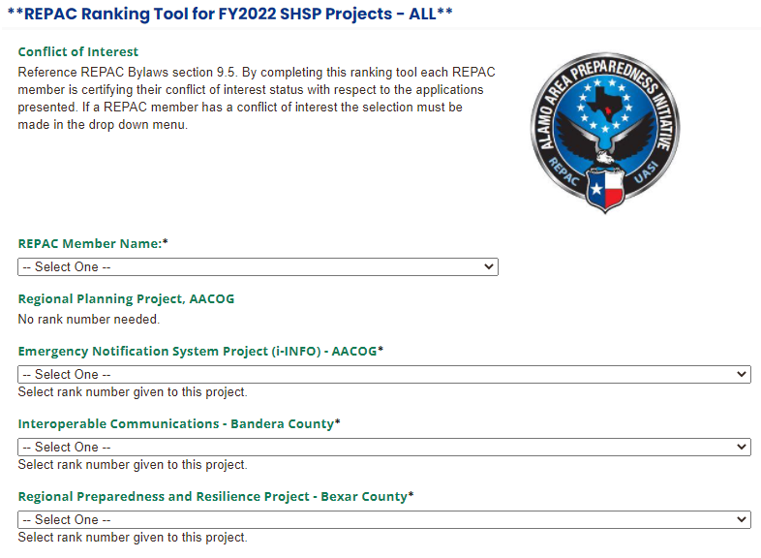

FY 2022 SHSP AACOG Subcommittee Ranking Sheet

