Profile Information
Applicant Agency Name:
Project Title:
Division or Unit to Administer the Project:
Address Line 1:
Address Line 2:
City/State/Zip:
Start Date:
End Date:
State Homeland Security Projects Request for Application (RFA) Designation:
(Choose one)
- Regular SHSP Project
- Law Enforcement Prevention of Terroristic Activities (LEPTA) SHSP Project
Regional Council of Governments (COG) within the Project's Impact Area:
Alamo Area Council of Governments
Headquarter County:
Provide answer here
Counties within Project's Impact Area:
Provide answer here
Project Summary:
Briefly summarize the project, including proposed activities and intended impact.
Provide answer here
Problem Statement:
Provide a detailed account of the issues, threats or hazards that your project will target. For federal Homeland Security Grants, include specific references to the regional Threat and Hazard Identification and Risk Assessment (THIRA), as applicable.
Provide answer here
Existing Capability Levels:
Describe the existing capability levels, including resources that are currently in place to support this project prior to the use of grant funds.
Provide answer here

Capability Gaps:
Describe the capability gaps which will be addressed by the project. For federal Homeland Security Grants, include specific references to the regional or statewide State Preparedness Report (SPR).
Provide answer here

Impact Statement:
Describe the project goals/objectives and how this project will maintain capabilities or reduce capability gaps.
Provide answer here
Homeland Security Priority Actions:
Identify the Texas Homeland Security Priority Action most closely aligned with this project. Each Priority Action is linked with an Objective from the Texas Homeland Security Strategic Plan (HSSP). List the Priority Action by number and text (e.g. 1.2.3 Expand and enhance the network of human sources that can provide detailed and relevant information on known or suspected terrorist and criminal enterprises.)
Provide answer here

Target Group:
Identify the target group and population expected to benefit from this project.
Provide answer here
Long-Term Approach:
Describe how the applicant agency will maintain the capabilities supported by this project without additional federal or state funds. If sustainment is dependent upon federal or state grants, describe the ongoing need for future grants, as applicable.
Provide answer here

AACOG Regional Supplemental Questions:

Mandatory Grant Workshop Attendance:
Was a representative from your agency present for one of the AACOG SHSP grant workshops? If so, please name the attendee below. Yes/No
Name

STEAR Participation:
Did your agency/jurisdiction participate in the 2023 National Special Events Data Call (NSEDC)? Yes/No

SARRA Participation:
Did your agency/jurisdiction utilize the San Antonio Regional Risk Assessment (SARRA)? Yes/No

WebEOC Participation:
Does your agency/jurisdiction utilize WebEOC for emergency response efforts and resource typing for mutual aid purposes?
Yes/No

Means of Ensuring Project is Shareable and Deployable:
Describe how the applicant agency will maintain the ability to share this asset/service with other jurisdictions in the region or deploy this asset to other jurisdictions in the region. By what means will other jurisdictions be able to request access to this project? How will other jurisdictions benefit from this project?
Provide answer here

Local Risk Assessment Findings
Describe the risks and hazards identified in your jurisdiction’s 2022-2023 Regional Risk Assessment. Describe how this project suits to mitigate, prevent, respond to, or prepare for those risks and hazards.
Provide answer here

Asset Maintenance:
If applicable, describe how the applicant agency will maintain the assets purchased under this project for the next 5 years. Describe what local or external funds will be budgeted to ensure that regional assets continue to be deployable and shareable with all jurisdictions in the region.
Provide answer here

Measures Information
Objective Output Measures
OUTPUT MEASURE | TARGET LEVEL
Number of exercises conducted.
Number of individuals participating in exercises.
Number of people trained.
Number of Special Response Team personnel provided with new or updated equipment.
Number of Special Response Teams created, maintained or enhanced.
Number of trainings conducted.

Homeland Security Information
Capabilities
Core Capability. Please Select One from reference table below:
Provide answer here
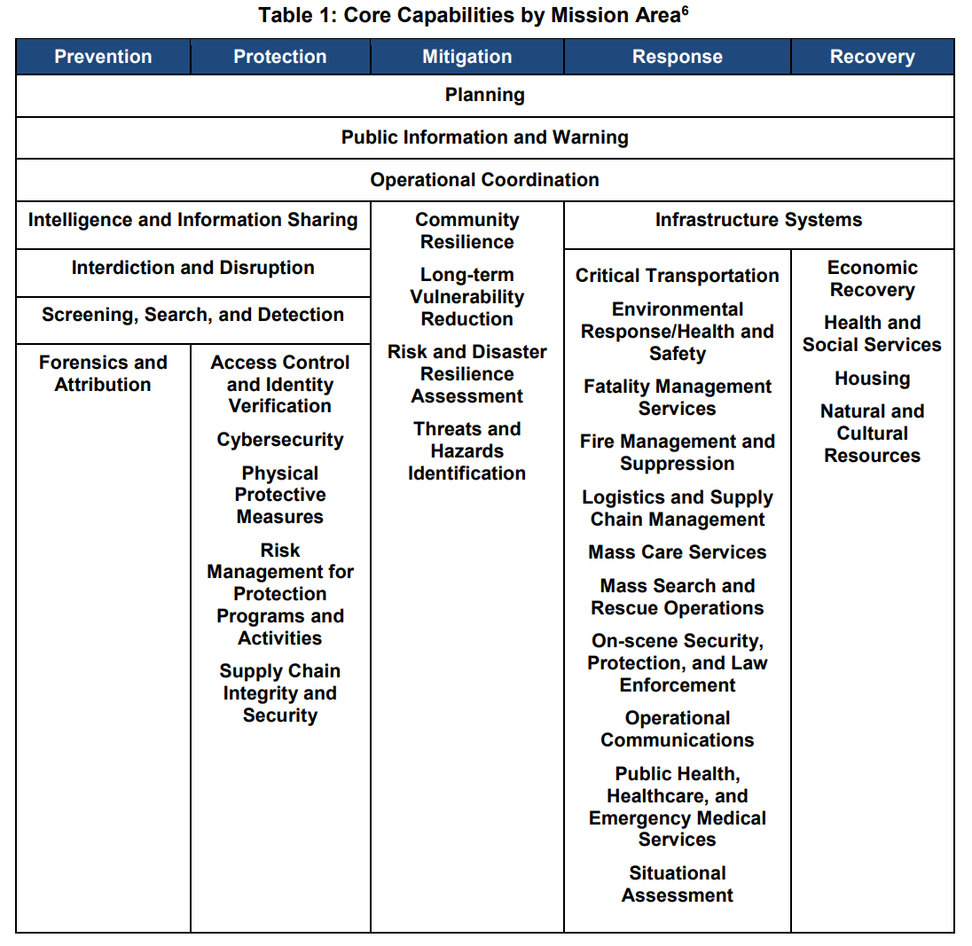

Additional information on these core capabilities can be found by following the link below:
https://www.fema.gov/media-library-data/1443799615171-2aae90be55041740f97e8532fc680d40/National_Preparedness_Goal_2nd_Edition.pdf

Identify if this investment focuses on building new capabilities or sustaining existing capabilities. Please Select One:
- Building New Capabilities
- Sustaining Existing Capabilities
Are the assets or activities Deployable or Shareable? Please Select One:
- Deployable
- Shareable
- Neither Deployable or Shareable
___ Check if this Investment requires new construction or renovation, retrofitting, or modification of existing structures
___Check if these funds will support a project that was previously funded with HSGP funding

**add AEL code description to the applications
Budget Details Information
Budget Information by Budget Line Item:
Categories: Personnel, Contractual/Professional Services, Travel/Training, Equipment, Supplies/Direct Operating Costs, Indirect Costs

CATEGORY | DESCRIPTION | OOG | TOTAL | UNIT/%

Budget Summary Information
Budget Summary Information by Budget Category:
CATEGORY | OOG | TOTAL
Contractual and Professional Services
Equipment
Personnel
Supplies and Direct Operating Expenses
Travel and Training
Budget Grand Total Information:
OOG | TOTAL
Useful Links:

- The Authorized Equipment List (AEL) is a list of approved equipment types allowed under FEMA’s preparedness grant programs.
https://www.fema.gov/authorized-equipment-list
- The Resource Typing Library Tool (RTLT), an online catalogue of national resource typing definitions and position qualifications provided by the Federal Emergency Management Agency (FEMA) National Integration Center (NIC). https://rtlt.preptoolkit.fema.gov/Public
- Compilation of Eligible Activity Descriptions for: Law Enforcement Terrorism Prevention (LETPA)
https://egrants.gov.texas.gov/FileDirectory/LETPA_Eligible_Activity_Descriptions_11032016.pdf

